Application fact sheet:

**Index page:**

I have created a light sequence game using web development languages such as HTML and JavaScript. When you run or load up the application using a web browser, the page will show up to the user. The title of each page is stated at the top for user navigation convenience. Additionally, the title is distinguished by a green bar with white text which is a contrast to the purple background to the rest of the page. The index page is a welcome page for the user so they understand what they are going to do. I have included a picture of a light bulb as well to make the page look more attractive. Also, when you hover over the navigation bar, the circle around the text changes colour to green to inform the user that they are hovering over the button. This is on every page.

Screenshot of index page on google chrome:

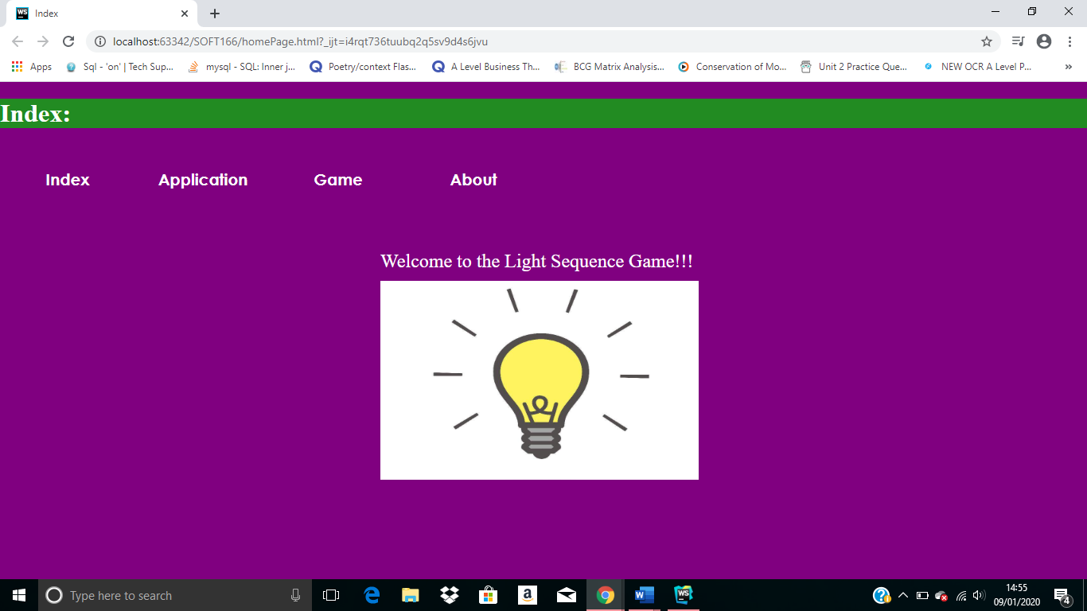

**Application page:**

The next page is the application page. This page covers the information about how the game will function and work. Briefly, this is an instructions page. Also, the title for the page is in green again like the previous page with white text. I have used ordered lists so that the user knows chronologically how the game works.

Screenshot of application page on google chrome:

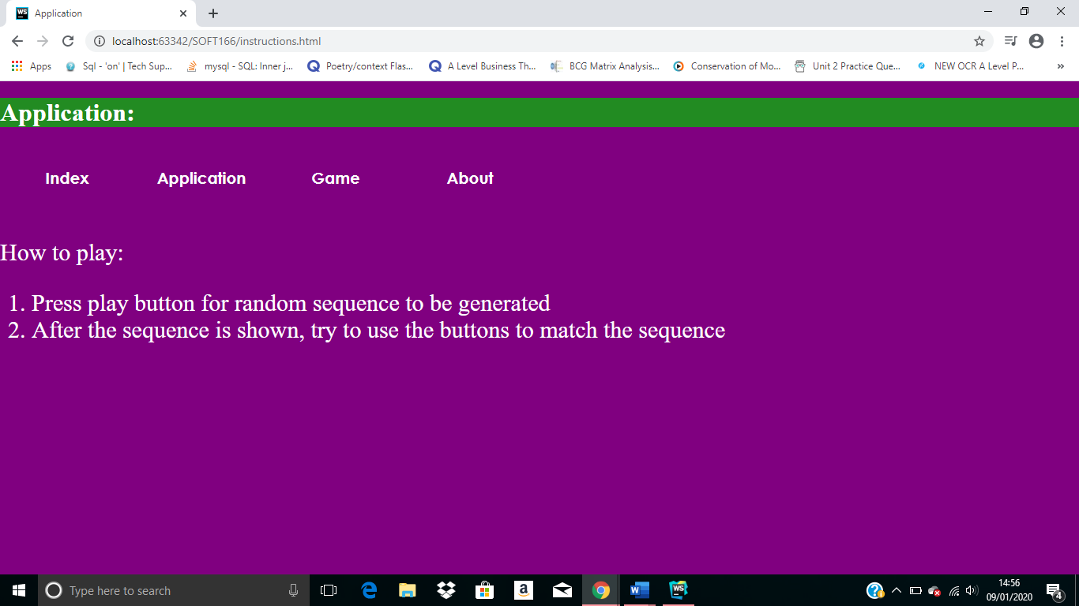

**Game Page:**

After that, there is the game page. This is the most important page for the user as it allows them to play the actual game. Just as on the previous page, there is a clear title. The buttons are numbered in the exact same order as the hue lights in the Smeaton 109 labs. This is to prevent the user from getting confused. The layout and structure are the same.

Furthermore, there is a play button and every time this is button is selected, the game would create a random sequence of light flashes. After the sequence of flashing lights, the user has to remember and select the buttons to show which lights have been selected including the order they flashed in. If it matches, the user will win and an alert window will pop up stating that they have won. However, if they do not match, an alert window will pop up stating they have lost. Also, every time the play button is selected by the user, a new random sequence will be created.

Screenshot of game page on google chrome:

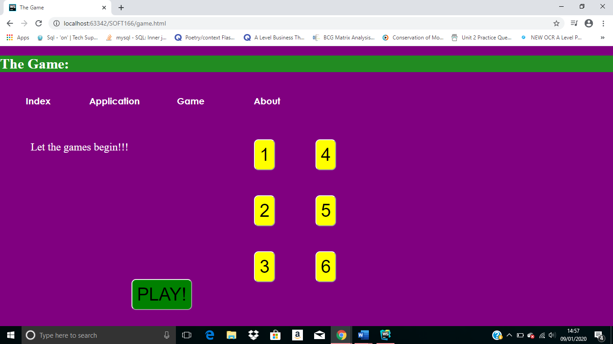

**About page:**

This is the last page on the website. This is a very simple web page where it shows the location of where the website was created. In addition, it provides a contact number.

Screenshot of about page on google chrome: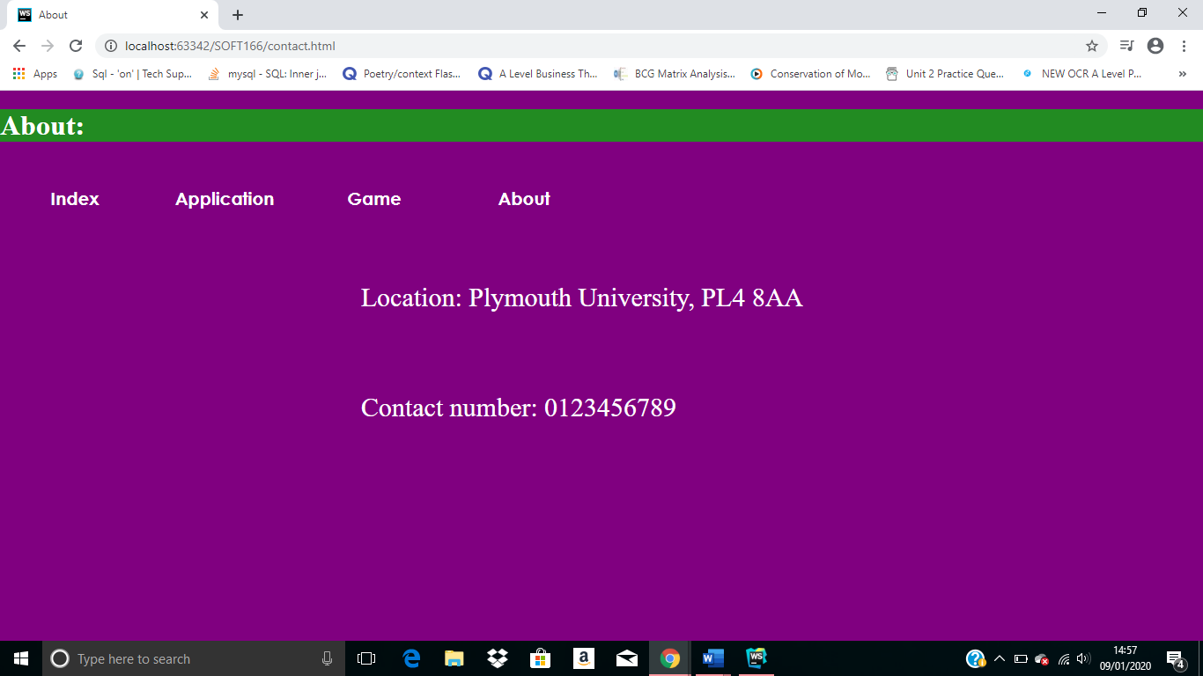

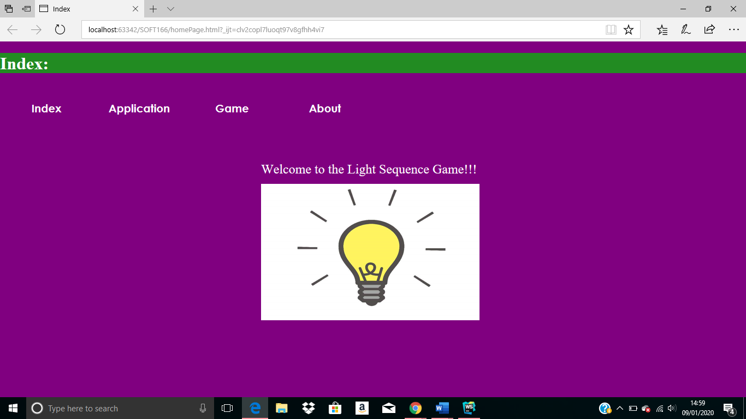Screenshot of all the webpages running on Microsoft Edge:

